RSU 16
Lauren Hendry
3 Aggregate Road
Poland, ME 04274

1-15-16Rlh SUBSTITUTE
3
Personal Information
Date | First Name |  |  |  | Last Name |  |  |  |  |  |  | Middle
Social Security Number |  | Mailing Address
Email Address |  |  |  |  |  | Telephone 1 |  |  |  |  | Telephone 2
Current Position |  |  |  | Title
Fingerprinting Status Current? Y N |  |  |  | If NO, please see enclosed instructions, as it is a requirement to be fingerprinted in order to be employed by RSU 16.
Do you hold a valid driver’s license? Y N  State held  Endorsement |  |  |  | If no, please explain
Position Desired (check all that apply)
⁮  ⁮Educational Technician Substitute - _______  Assistant/Secretary Substitute - _______  Food Service Substitute - ________  LPN Substitute - ________  Bus Driver/Monitor Substitute - _______  Van Driver/Monitor Substitute - _______  ⁮Mechanic Substitute - ________  ⁮Custodian/Maint. Substitute - ________  ⁮ |  |  |  |  |  |  | ⁮  ⁮  Level Desired: (check all that apply)  ⁮ PreK-Kindergarten - _________  ⁮ Elementary - _________  ⁮ Middle - ________  ⁮ High School - ________ |  |  |  |  |  |  |  | ⁮  ⁮
If you have a specialty area, please indicate specific subject…………
Educational Background (Include transcripts, if possible)
School and State Attended |  |  |  | Dates Attended |  |  |  |  |  | Graduated/Degree
School and State Attended |  |  |  | Dates Attended |  |  |  |  |  | Graduated/Degree
School and State Attended |  |  |  | Dates Attended |  |  |  |  |  | Graduated/Degree
Previous Employment History (Include three (3) current/signed letters of reference)
Employer Name, Address, Contact # |  |  | Immediate Supervisor |  |  |  |  |  | Dates Employed |  |  |  | Reason For Leaving
Employer Name, Address, Contact # |  |  | Immediate Supervisor |  |  |  |  |  | Dates Employed |  |  |  | Reason For Leaving
Employer Name, Address, Contact # |  |  | Immediate Supervisor |  |  |  |  |  | Dates Employed |  |  |  | Reason For Leaving
References (List three (3) names of no relation)
Name and Address |  |  | Title |  |  |  |  | Email Address |  |  |  |  |  | Telephone
Name and Address |  |  | Title |  |  |  |  | Email Address |  |  |  |  |  | Telephone
Name and Address |  |  | Title |  |  |  |  | Email Address |  |  |  |  |  | Telephone
Background | Yes | No
- Have you ever been disciplined, discharged, or asked to resign from a prior position?
- Have you ever resigned from a prior position after a complaint has been received against you or conduct was under investigation or review?
- Has your contract in a prior position ever been non-renewed?
- Have you ever not been nominated for re-employment in a prior position or ever had your nomination for re-employment not be approved?
- Have you ever been charged with or investigated for sexual abuse or harassment of another person?
- Have you ever entered a plea of guilty or “no contest” (nolo contendere) to any crime other than a minor traffic offense?
- Have you ever been convicted of a crime, other than a minor traffic offense?
- Have you ever had a professional license or certificate suspended/revoked in any state, or have you ever voluntarily surrendered, temporarily or permanently, a professional license or certificate in any state?
- Has any court ever deferred, filed, or dismissed proceedings without a finding of guilty and required you to pay a fine, penalty, or court costs and/or imposed a requirement as to your behavior or conduct for a period of time in connection with any crime other than a minor traffic offense?
If you answered YES in this section, provide full details as an attachment. Include court actions, the date, offense in question, and the address of the court involved. Conviction or other disposition of a crime is not necessarily an automatic bar to employment.

Signature
NOTICE: All application materials become the property of RSU 16. None will be returned. Providing any false or misleading information on this application or employment screening process shall be fully sufficient grounds to refuse to employ the applicant - or if the applicant has been employed, to immediately dismiss the application/employee.

RSU 16 does not discriminate in the operation of its educational and employment policies and will honor all appropriate laws relative to discrimination.

My signature below constitutes authorization to check my employment history and references, including without limitation, criminal arrest and conviction record checks and release of investigatory information possessed by any state, local, or federal agency. I further authorize those persons-agencies-entities, to fully provide RSU 16 information on the matters set forth above. I expressly waive in connection with any request or provision of such information, claims, including without limitation, defamation, emotional stress, invasion of privacy, or interference with contractual relations that I might otherwise have against RSU 16, its agents or officials, or against any provider of such information. I understand that information submitted with this application may be disclosed to a screening and/or interview committee. The committee may include school board members, administrators, school staff, and members of the community. I give my consent to this disclosure.

Signature ______________________________________________________ Date________________________________

Please Please return completed packet to: Lauren Hendry, RSU 16, 3 Aggregate Rd, Poland 04274

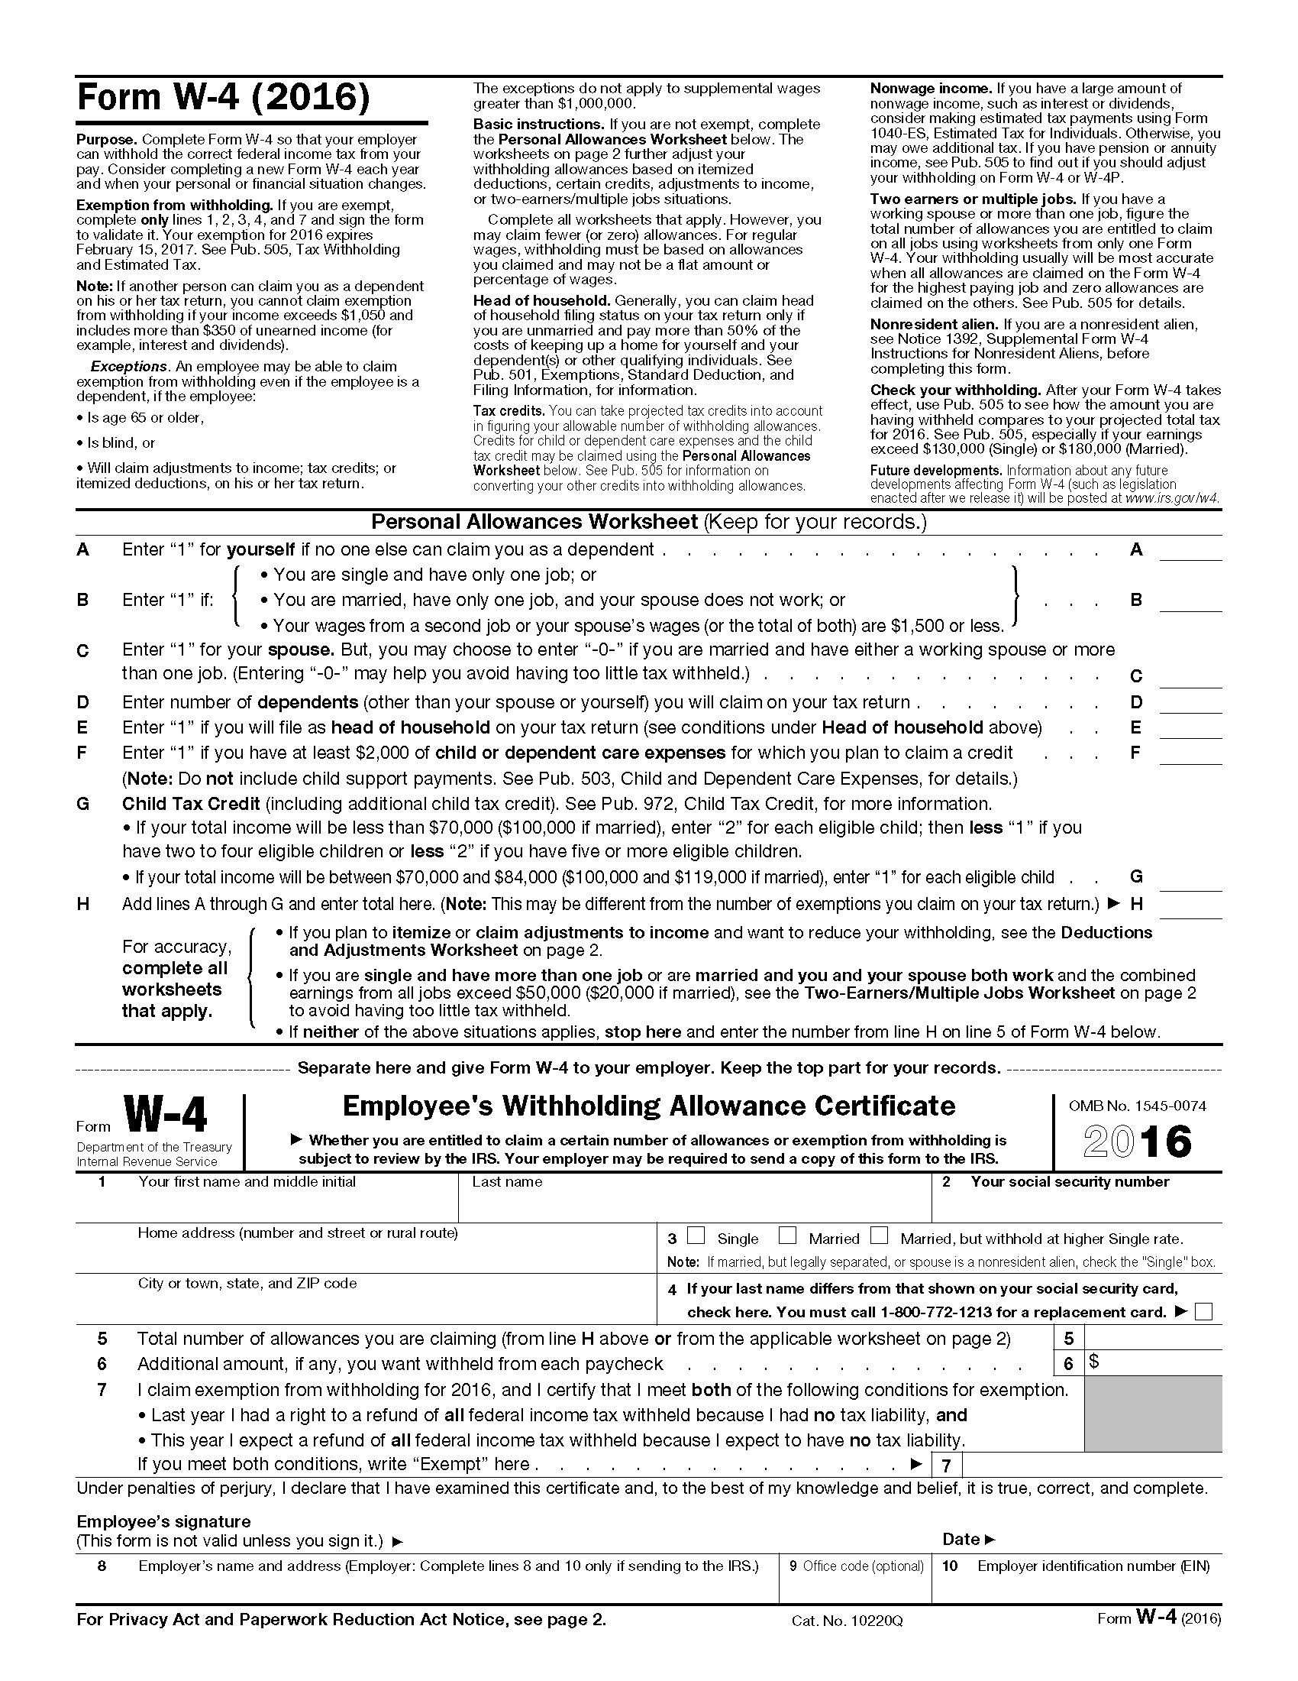

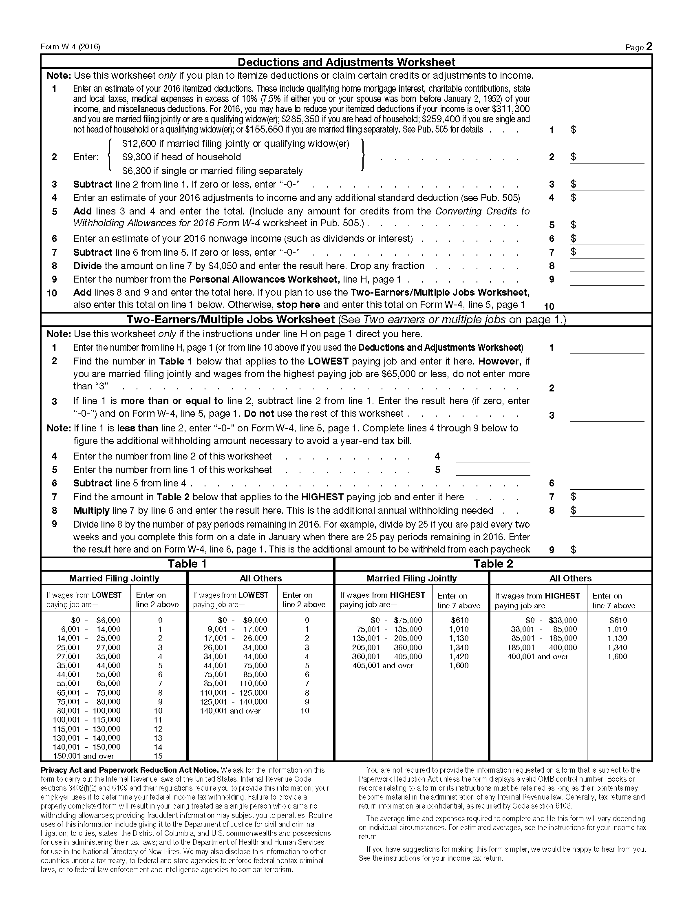

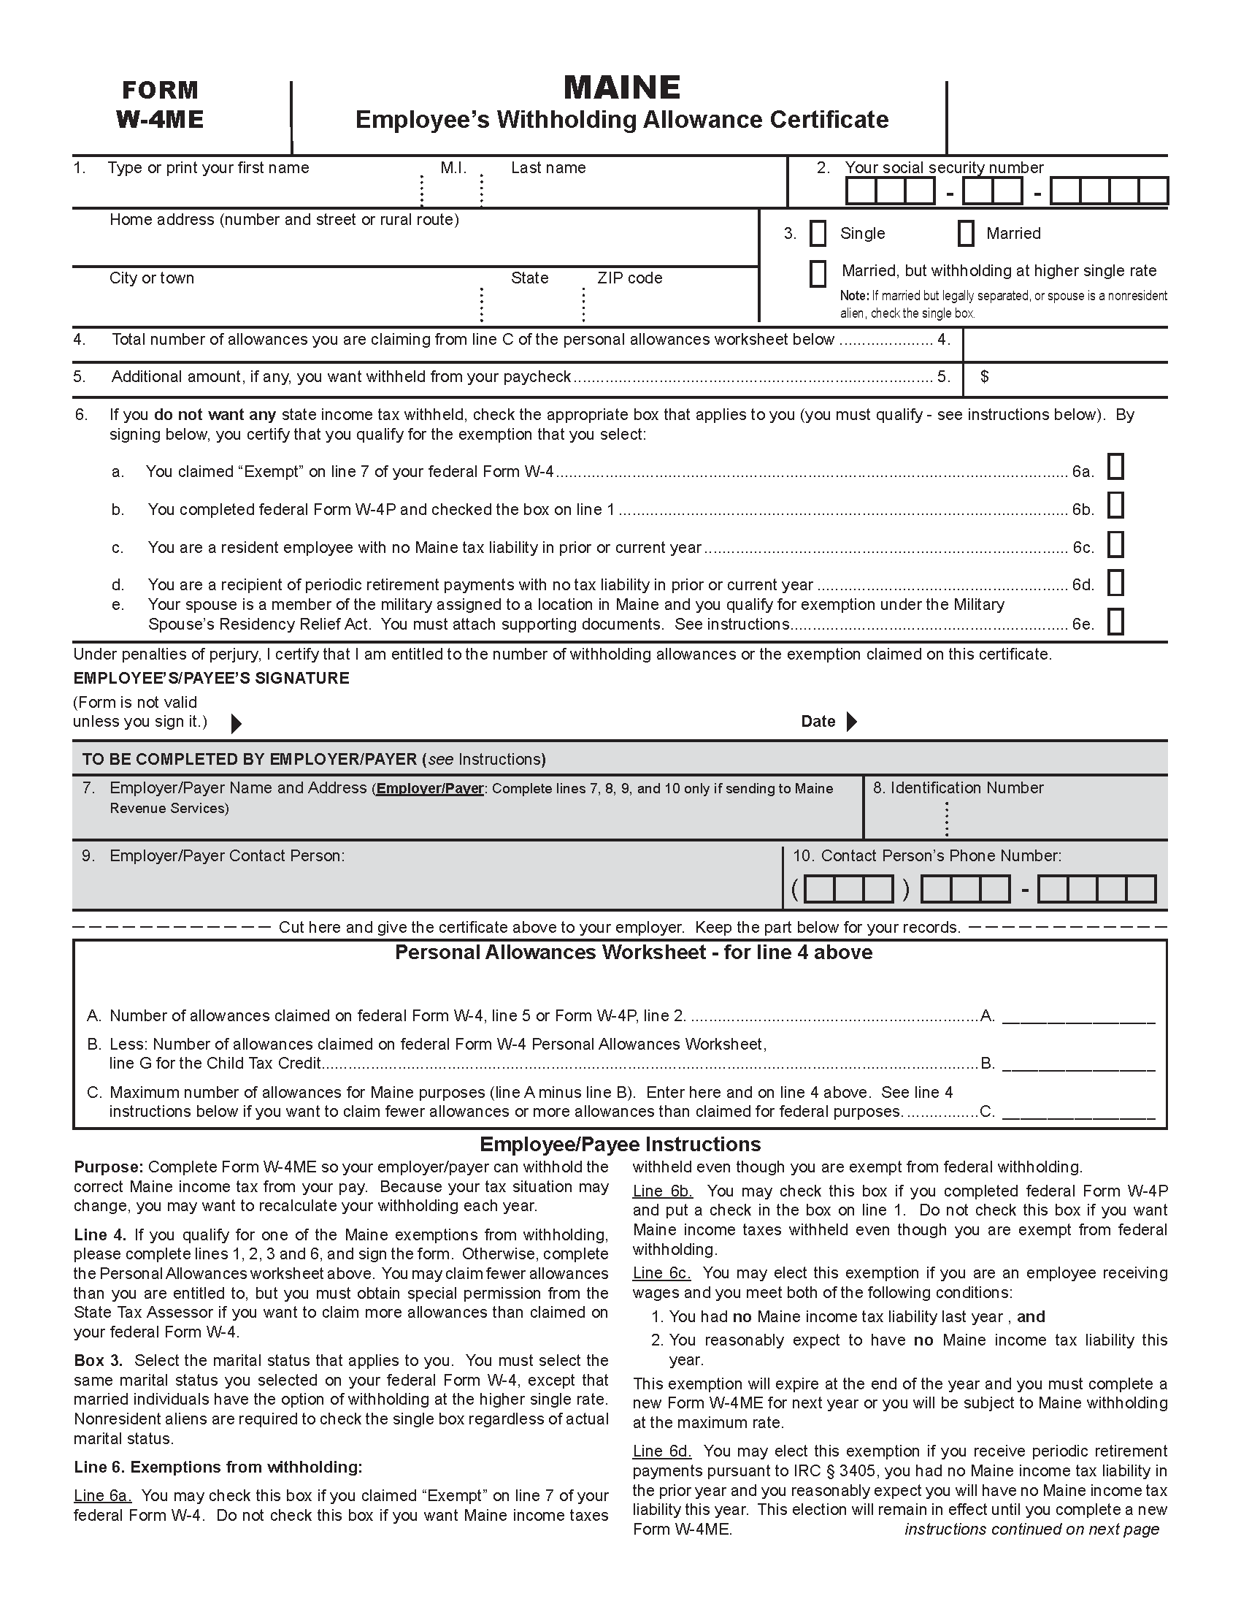

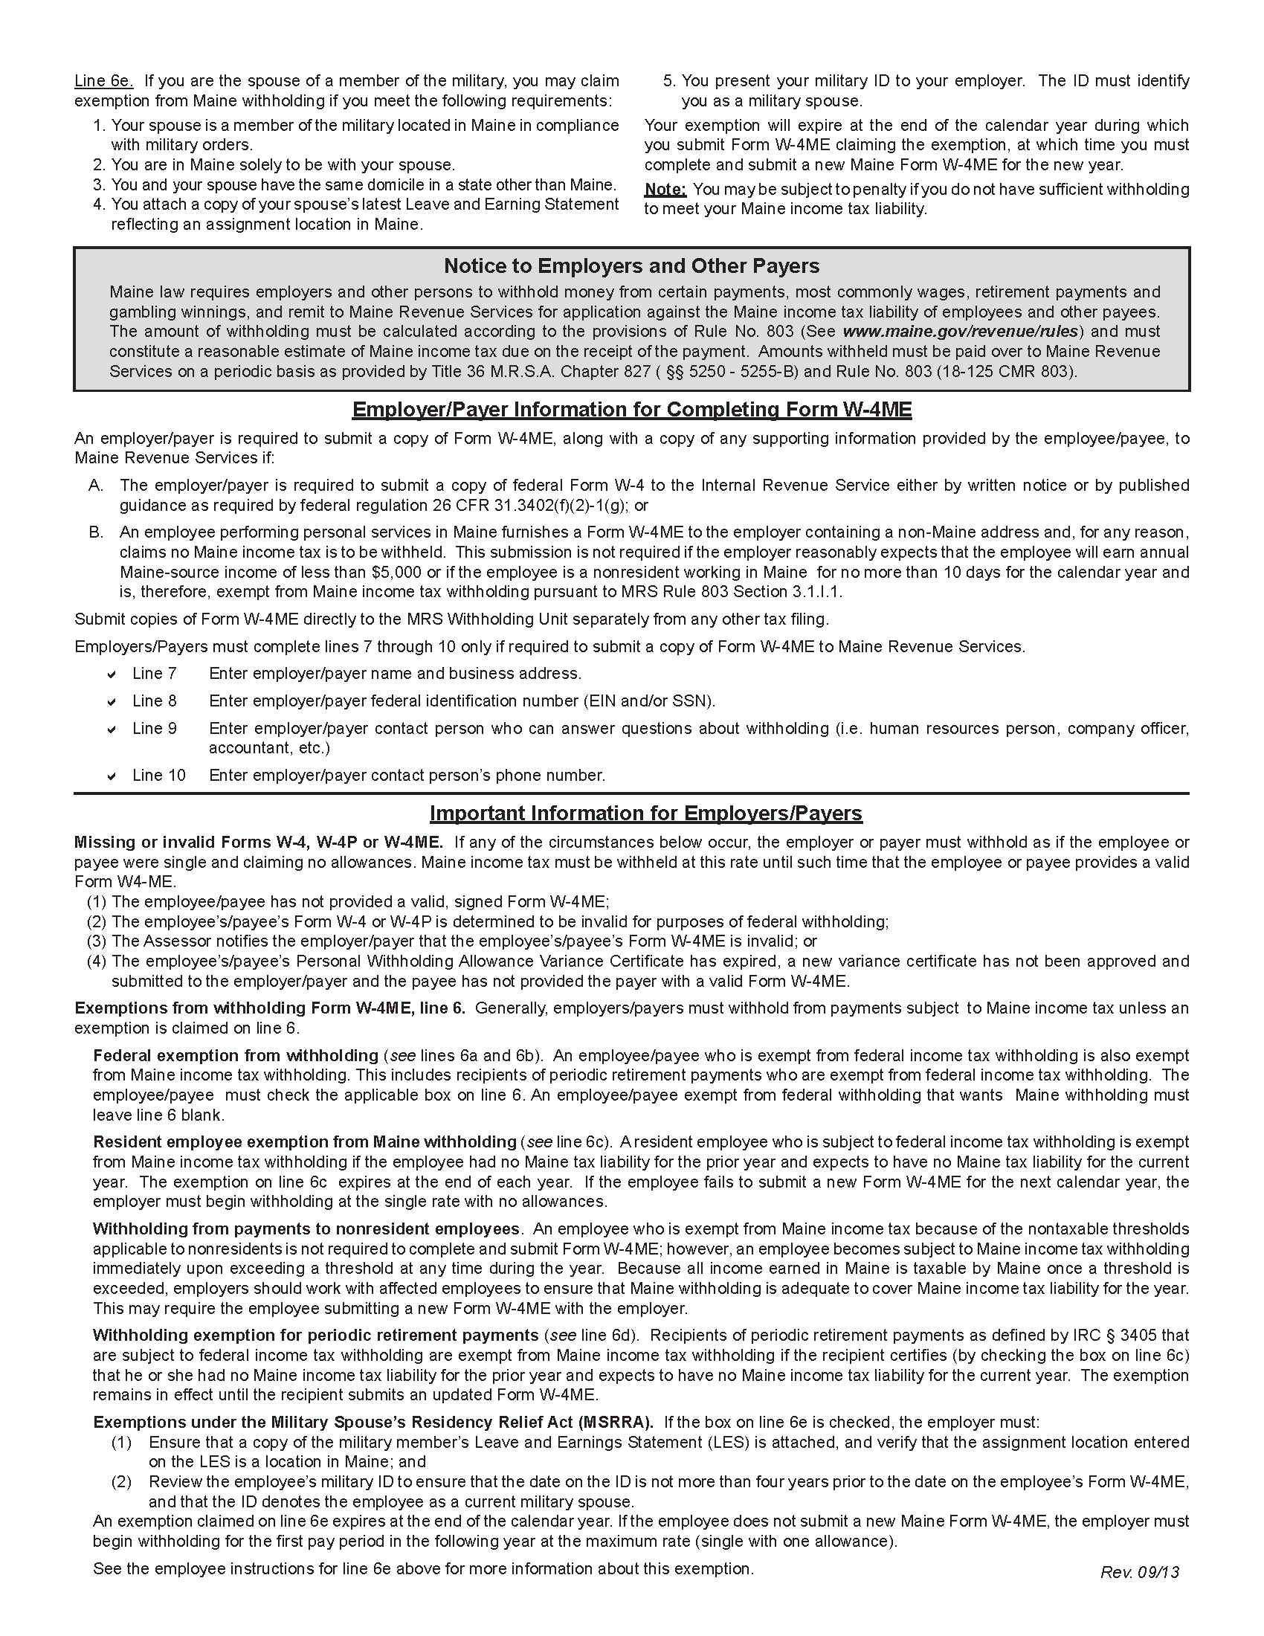

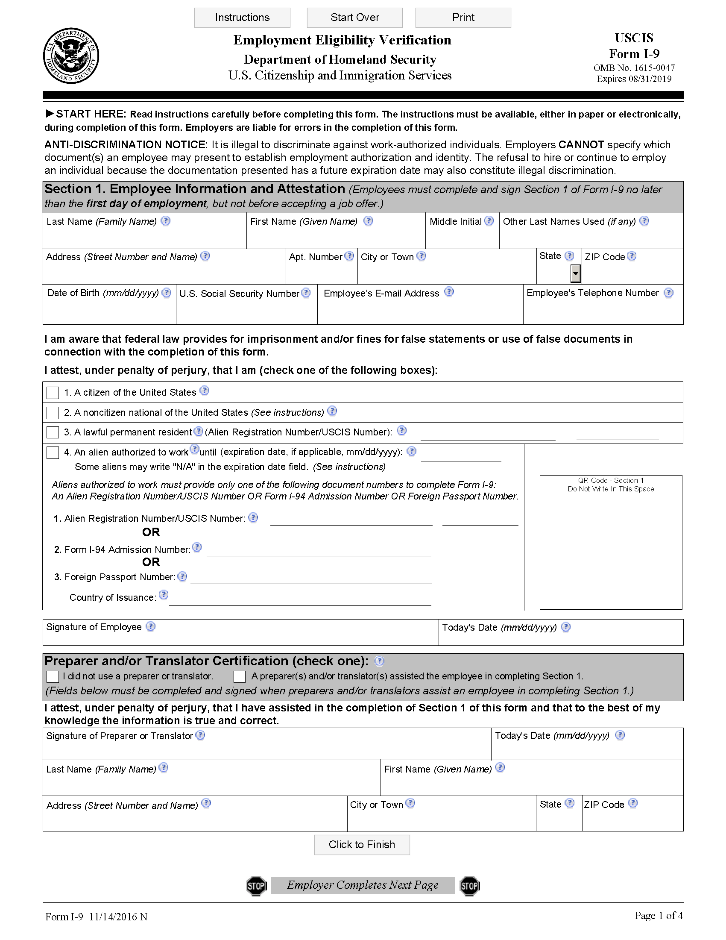

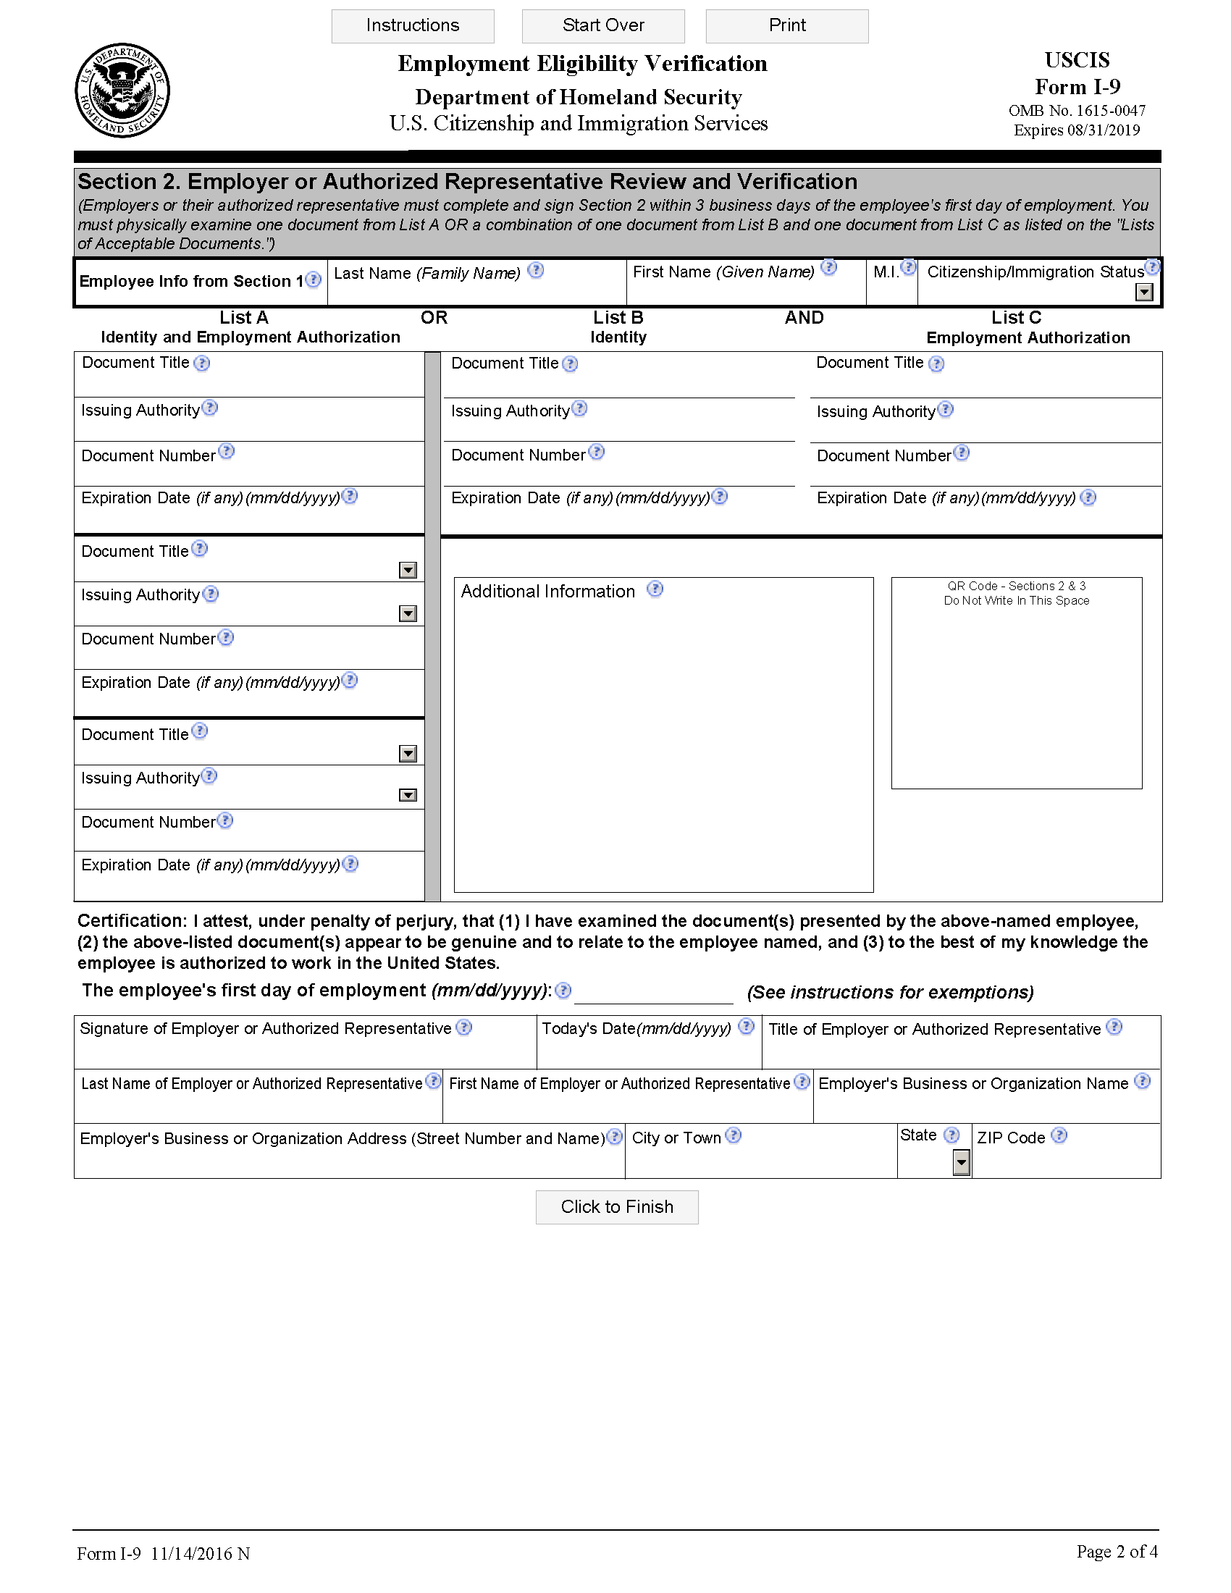

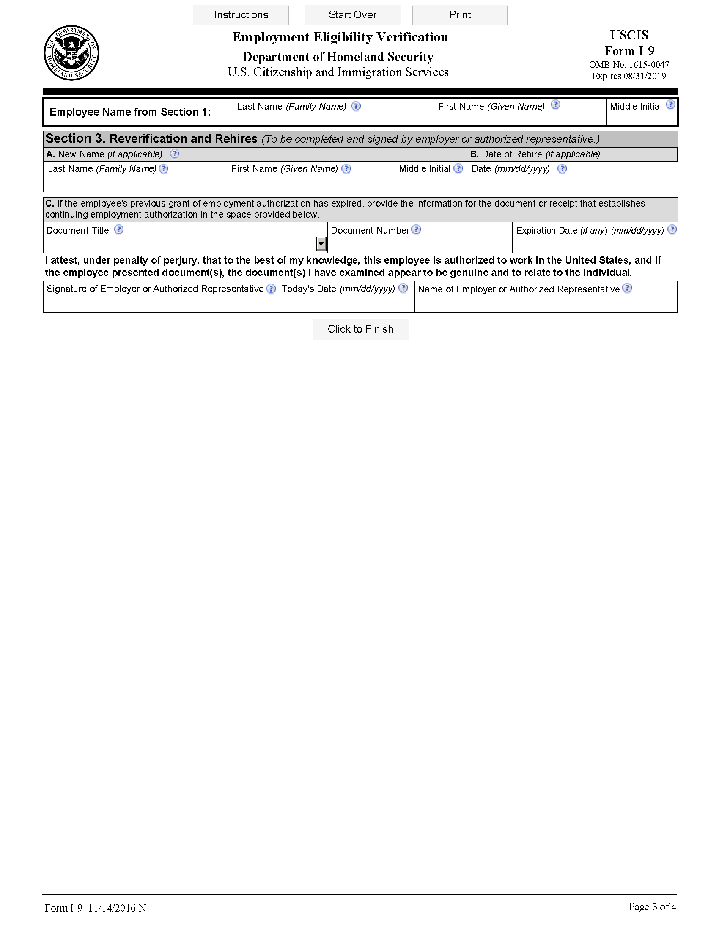

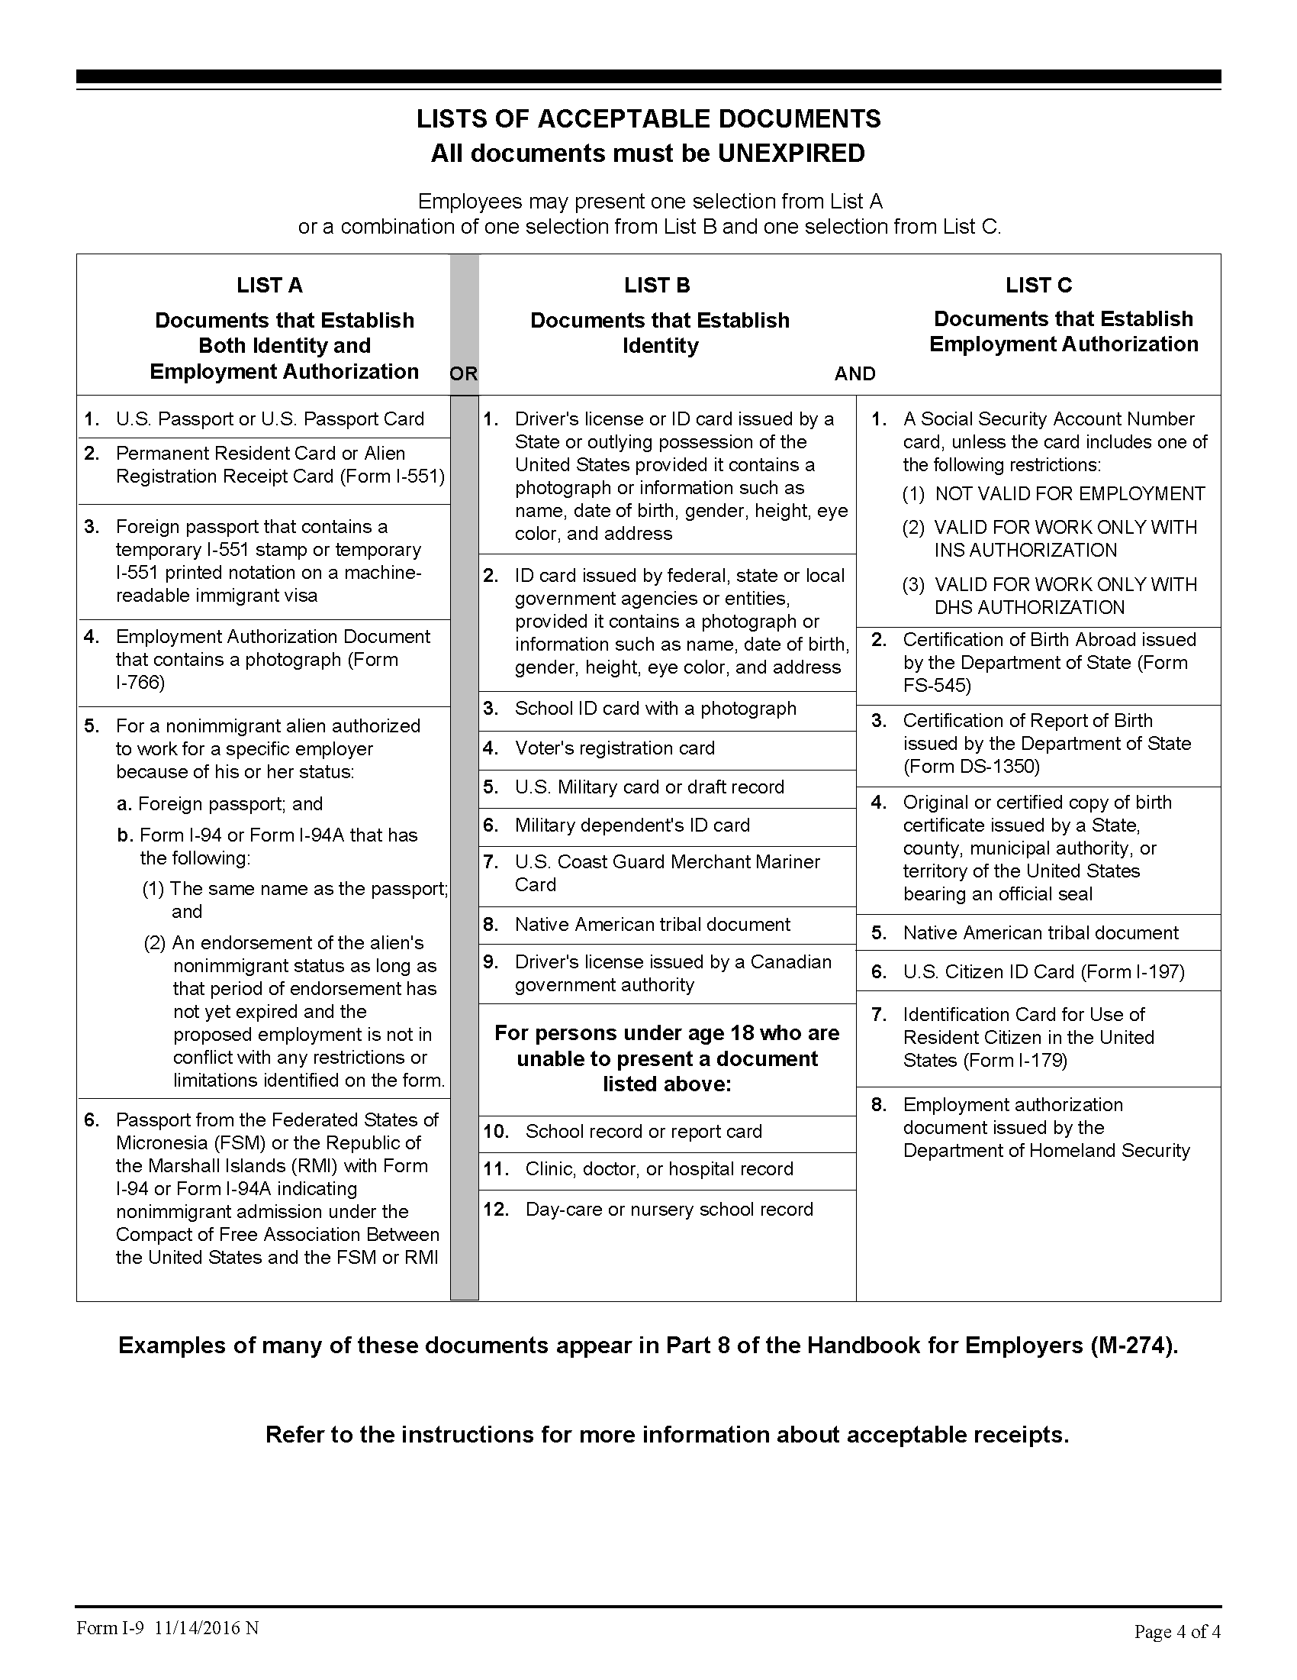

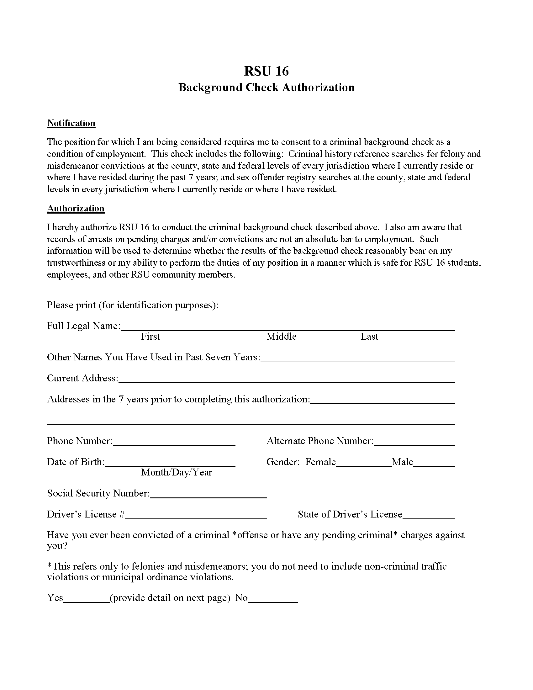

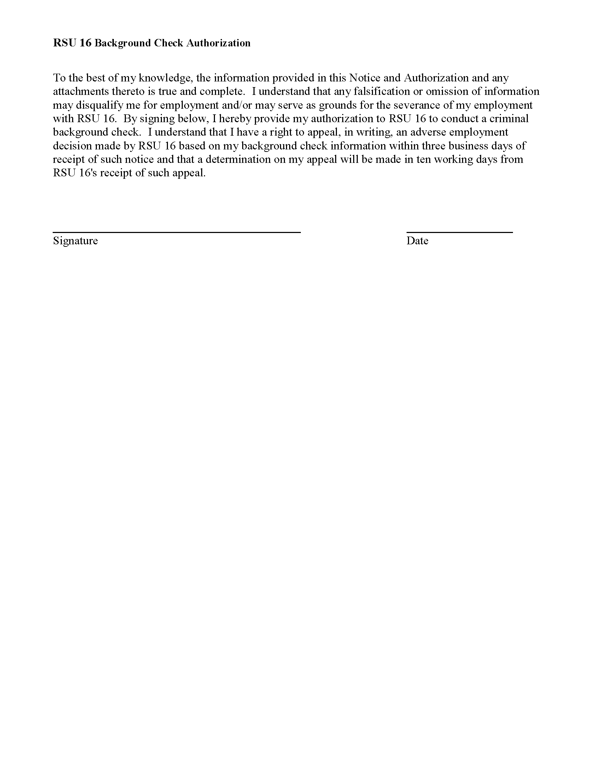

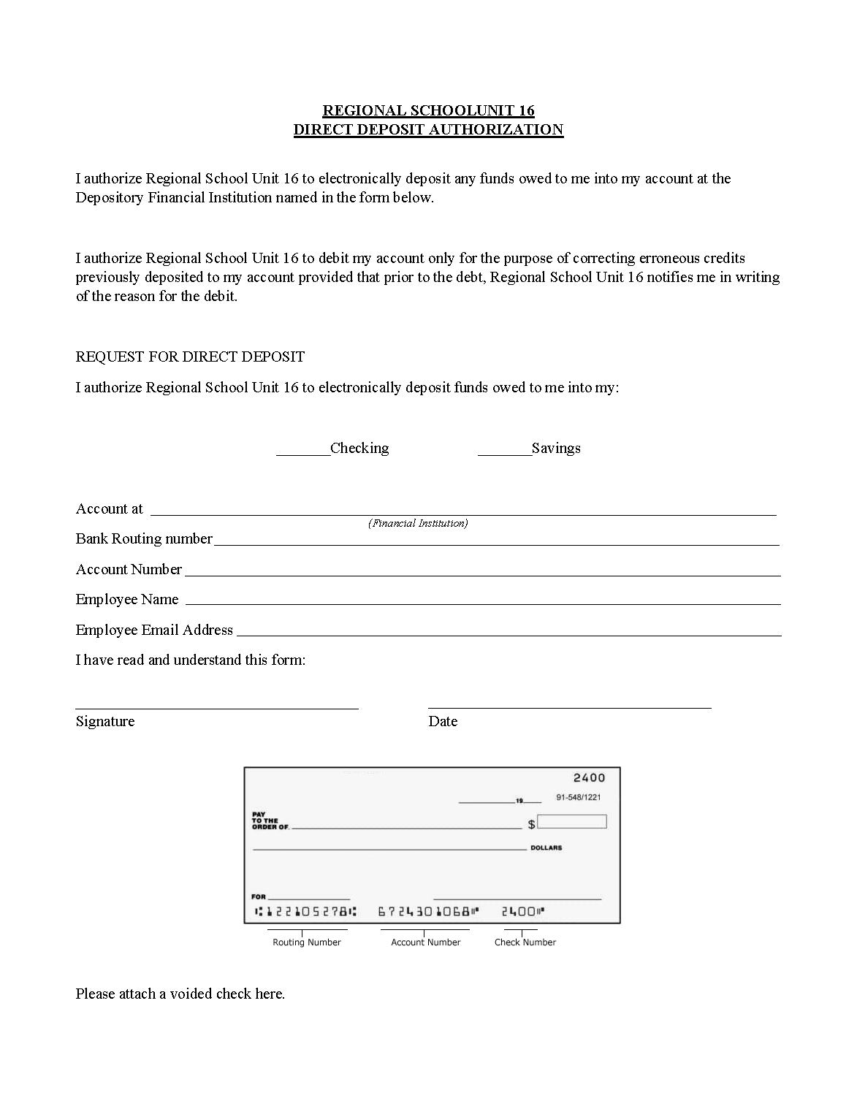

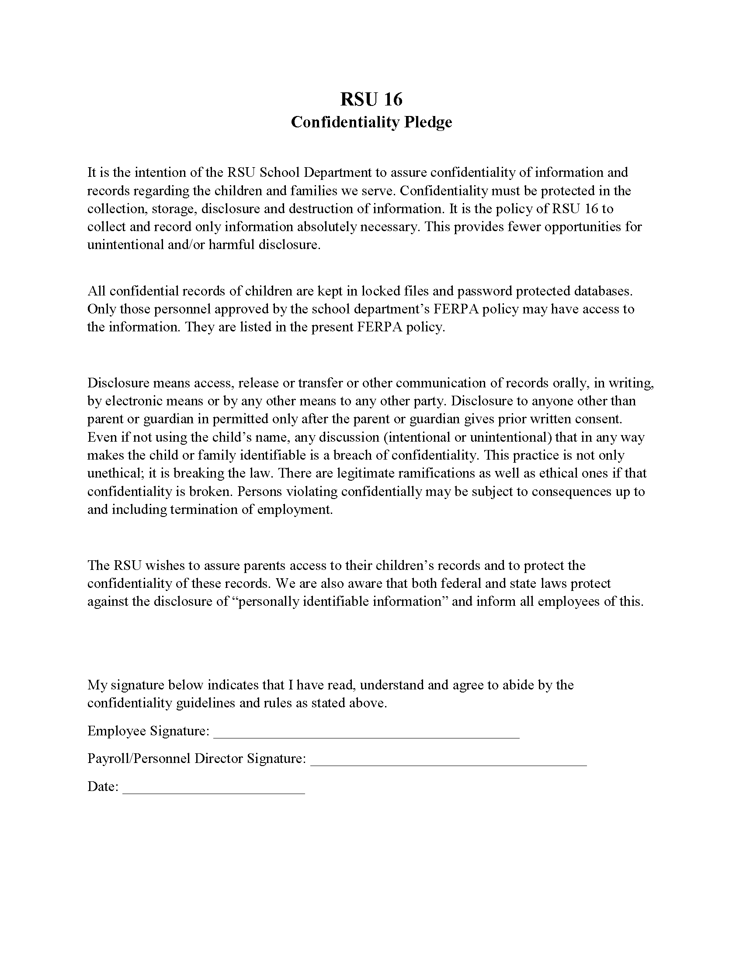

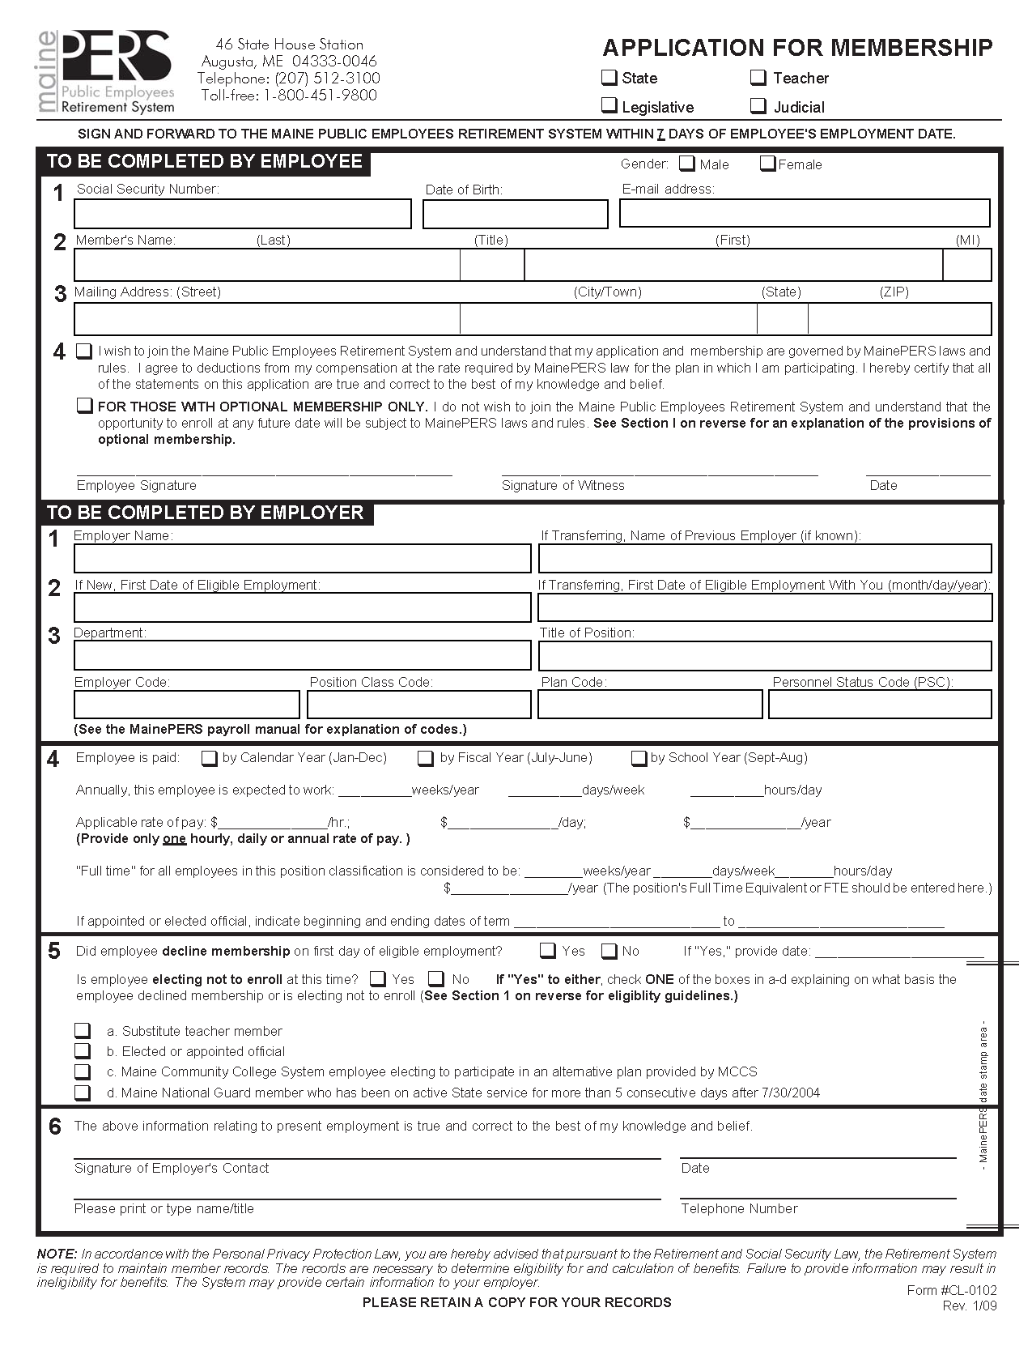

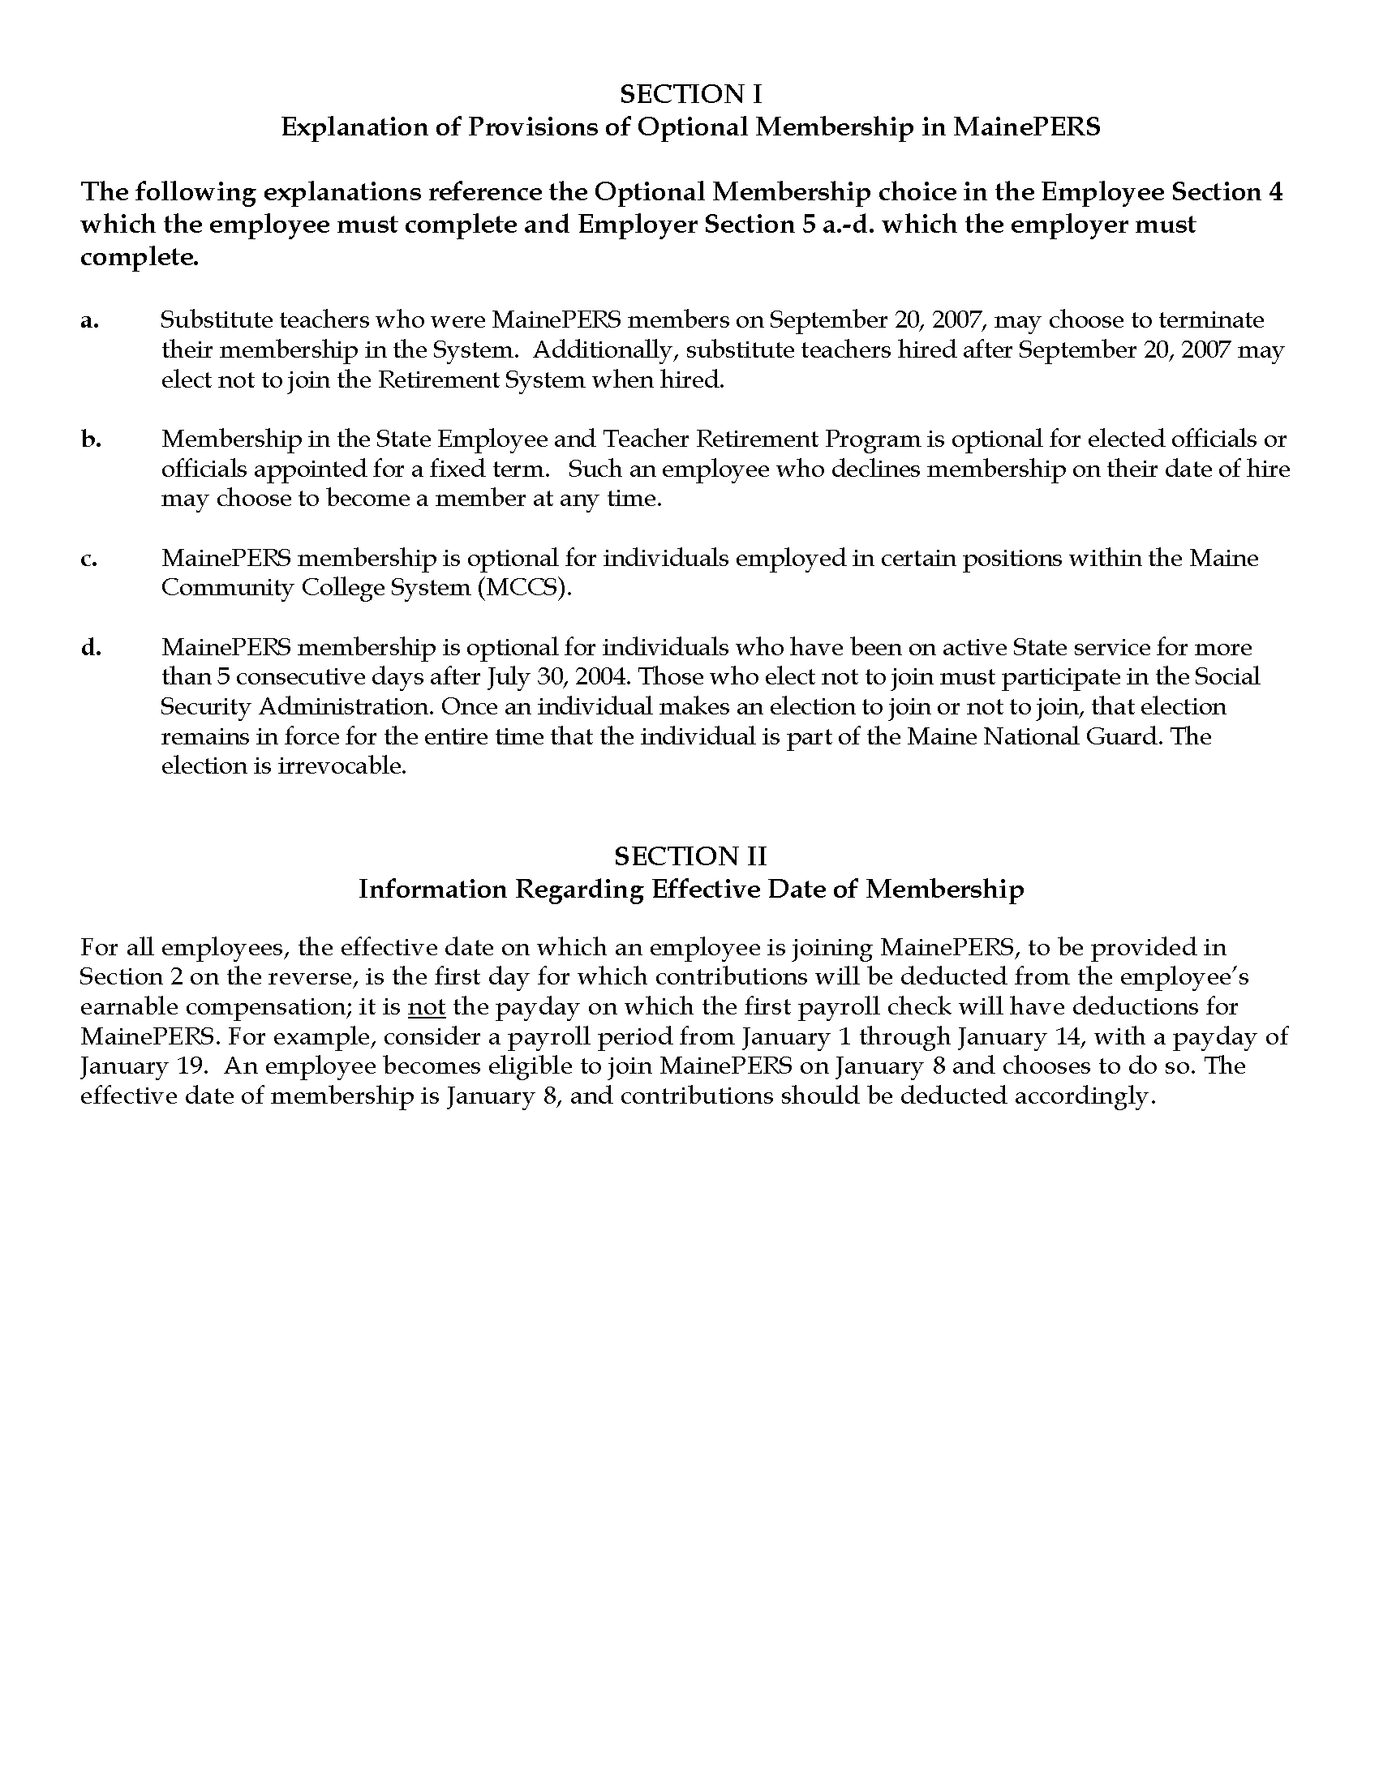

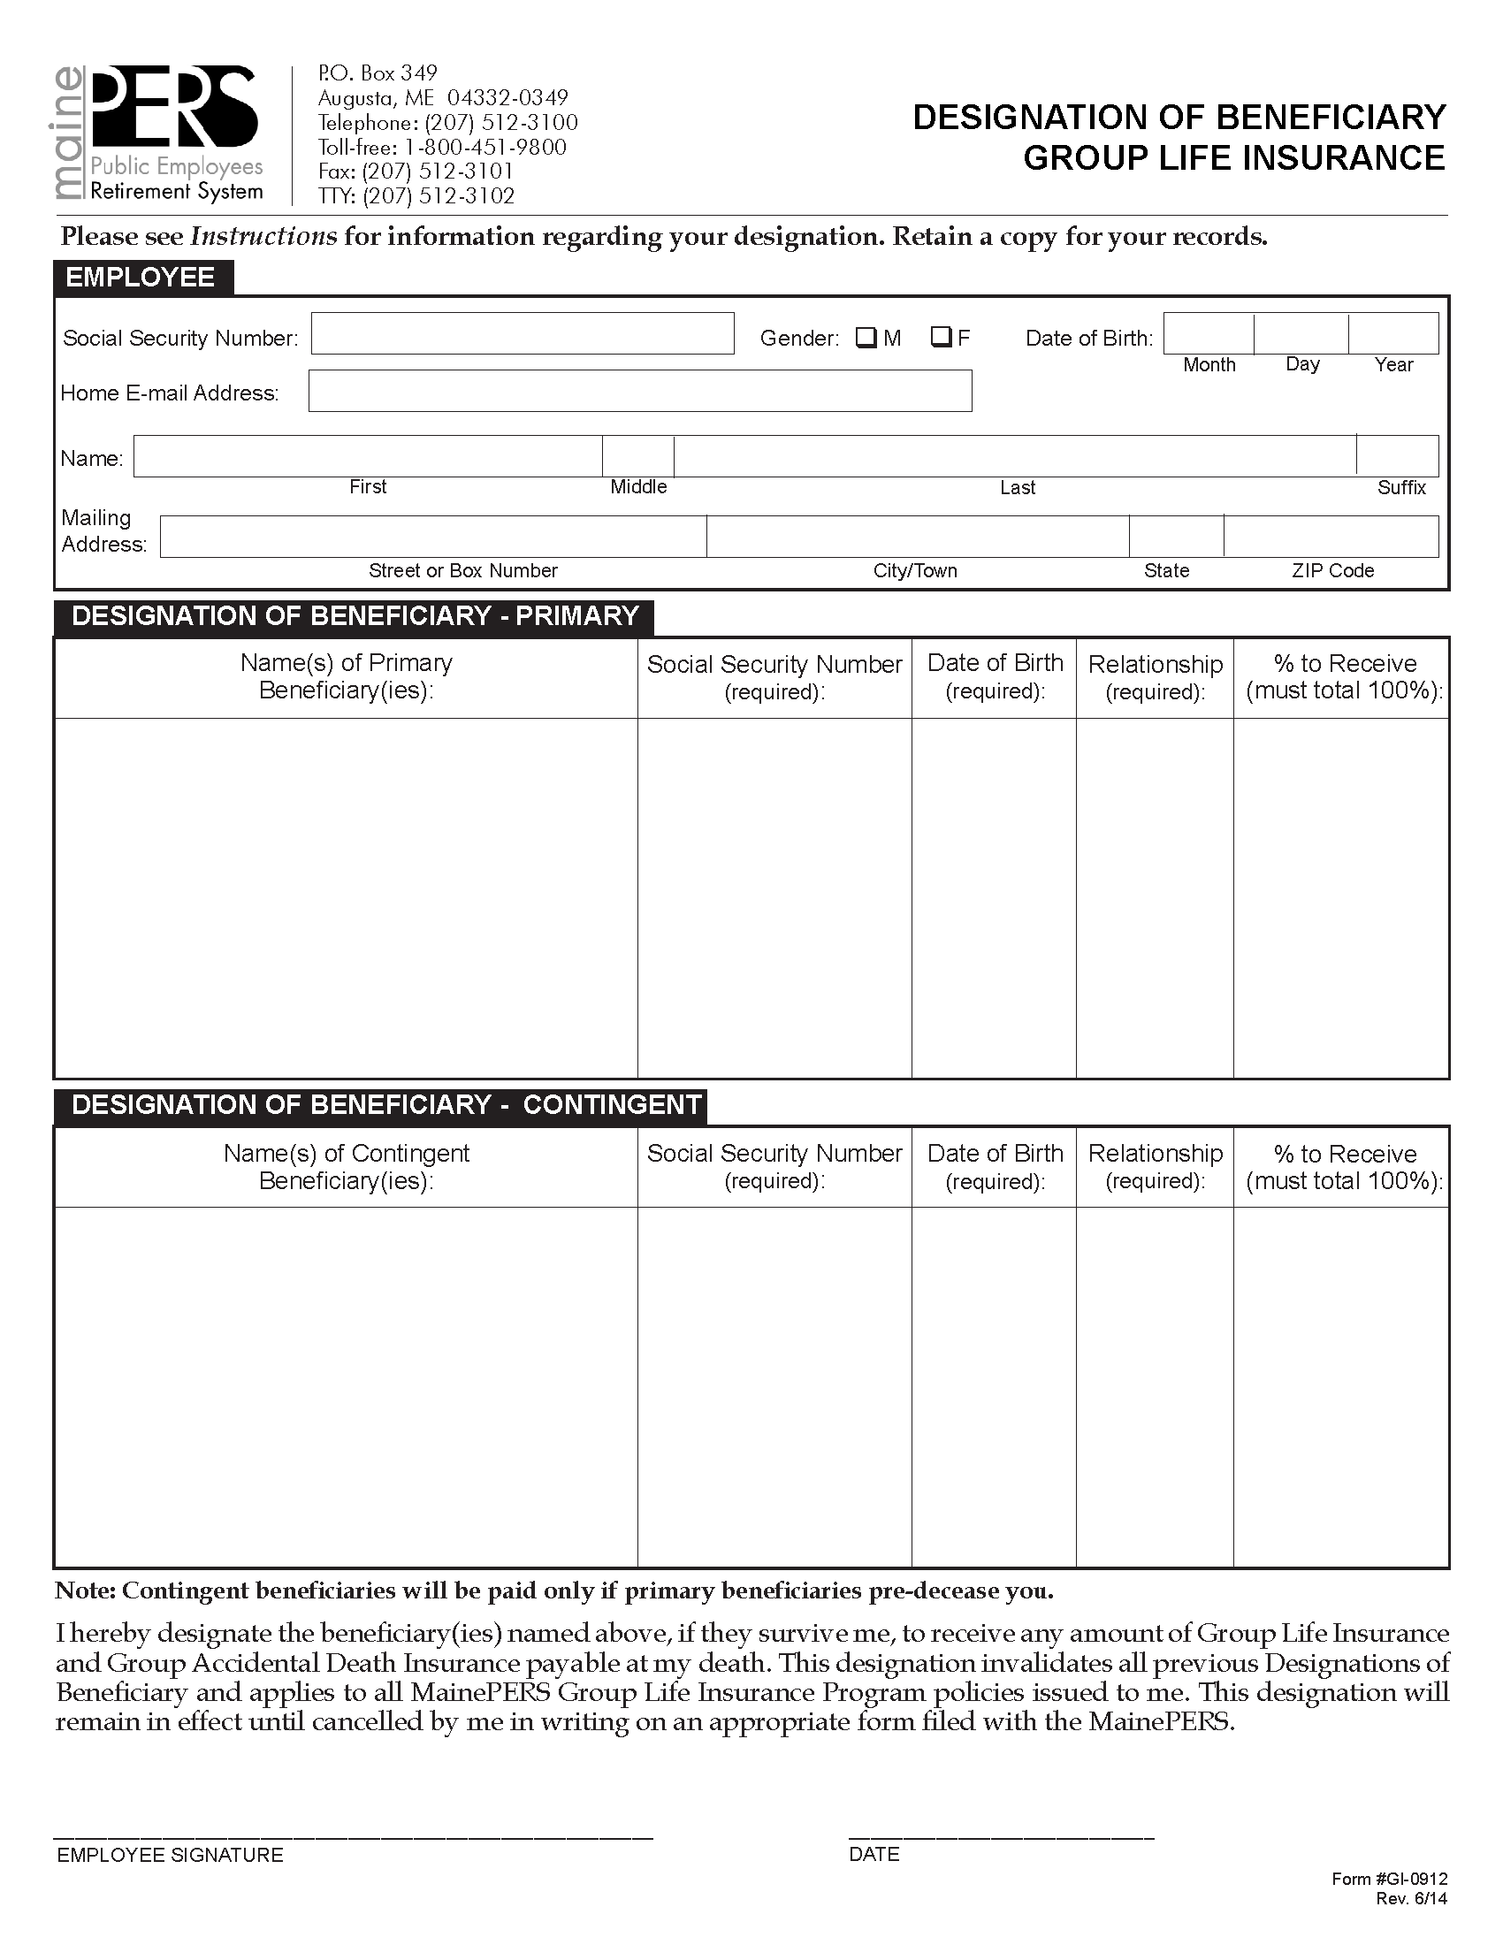

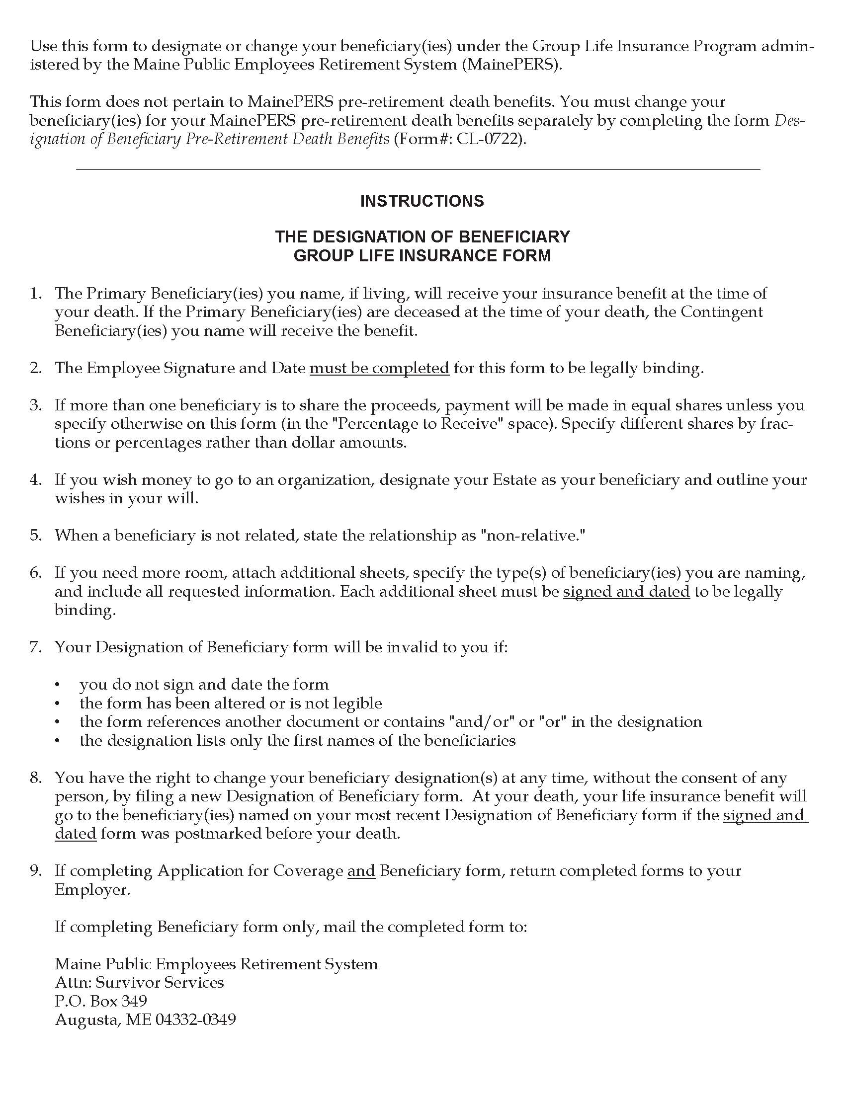

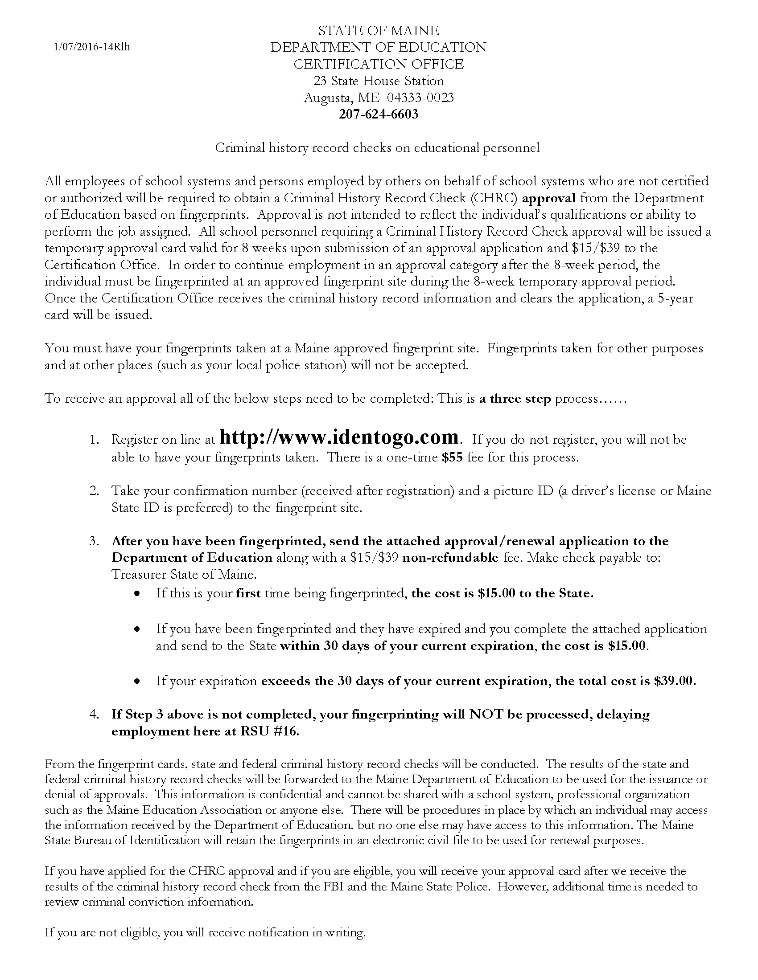

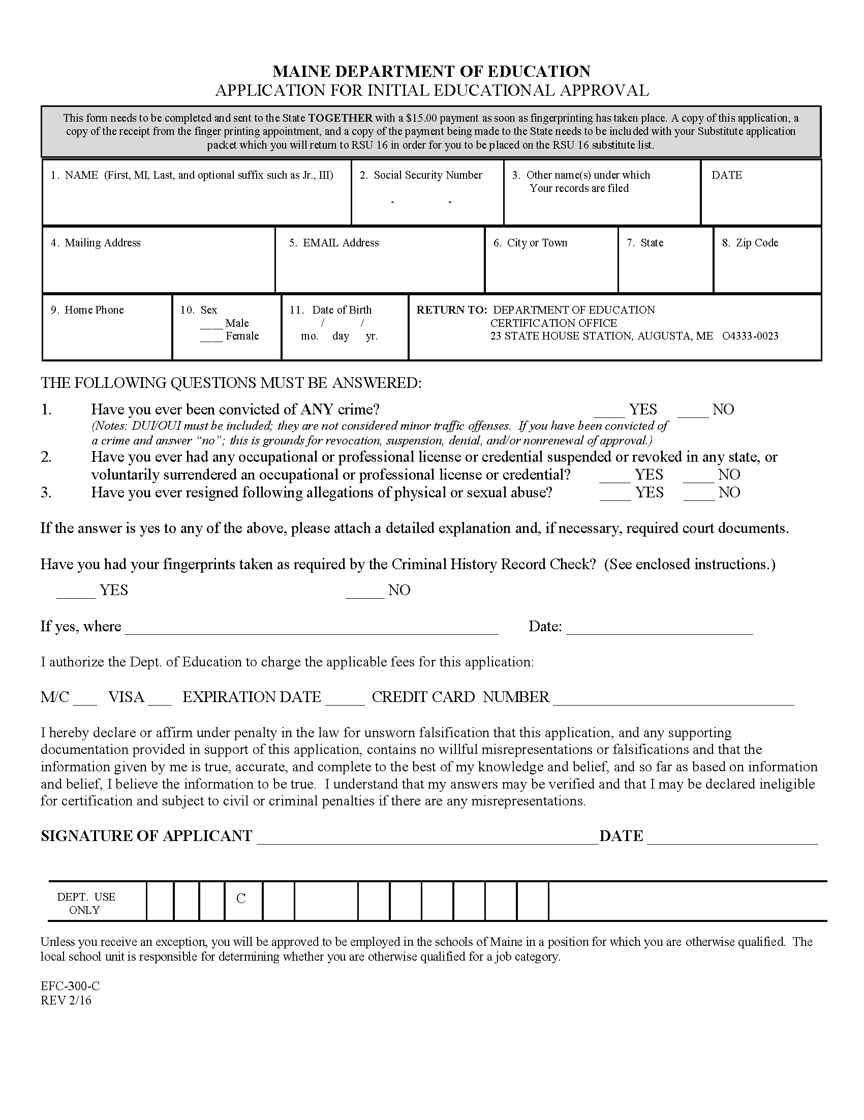

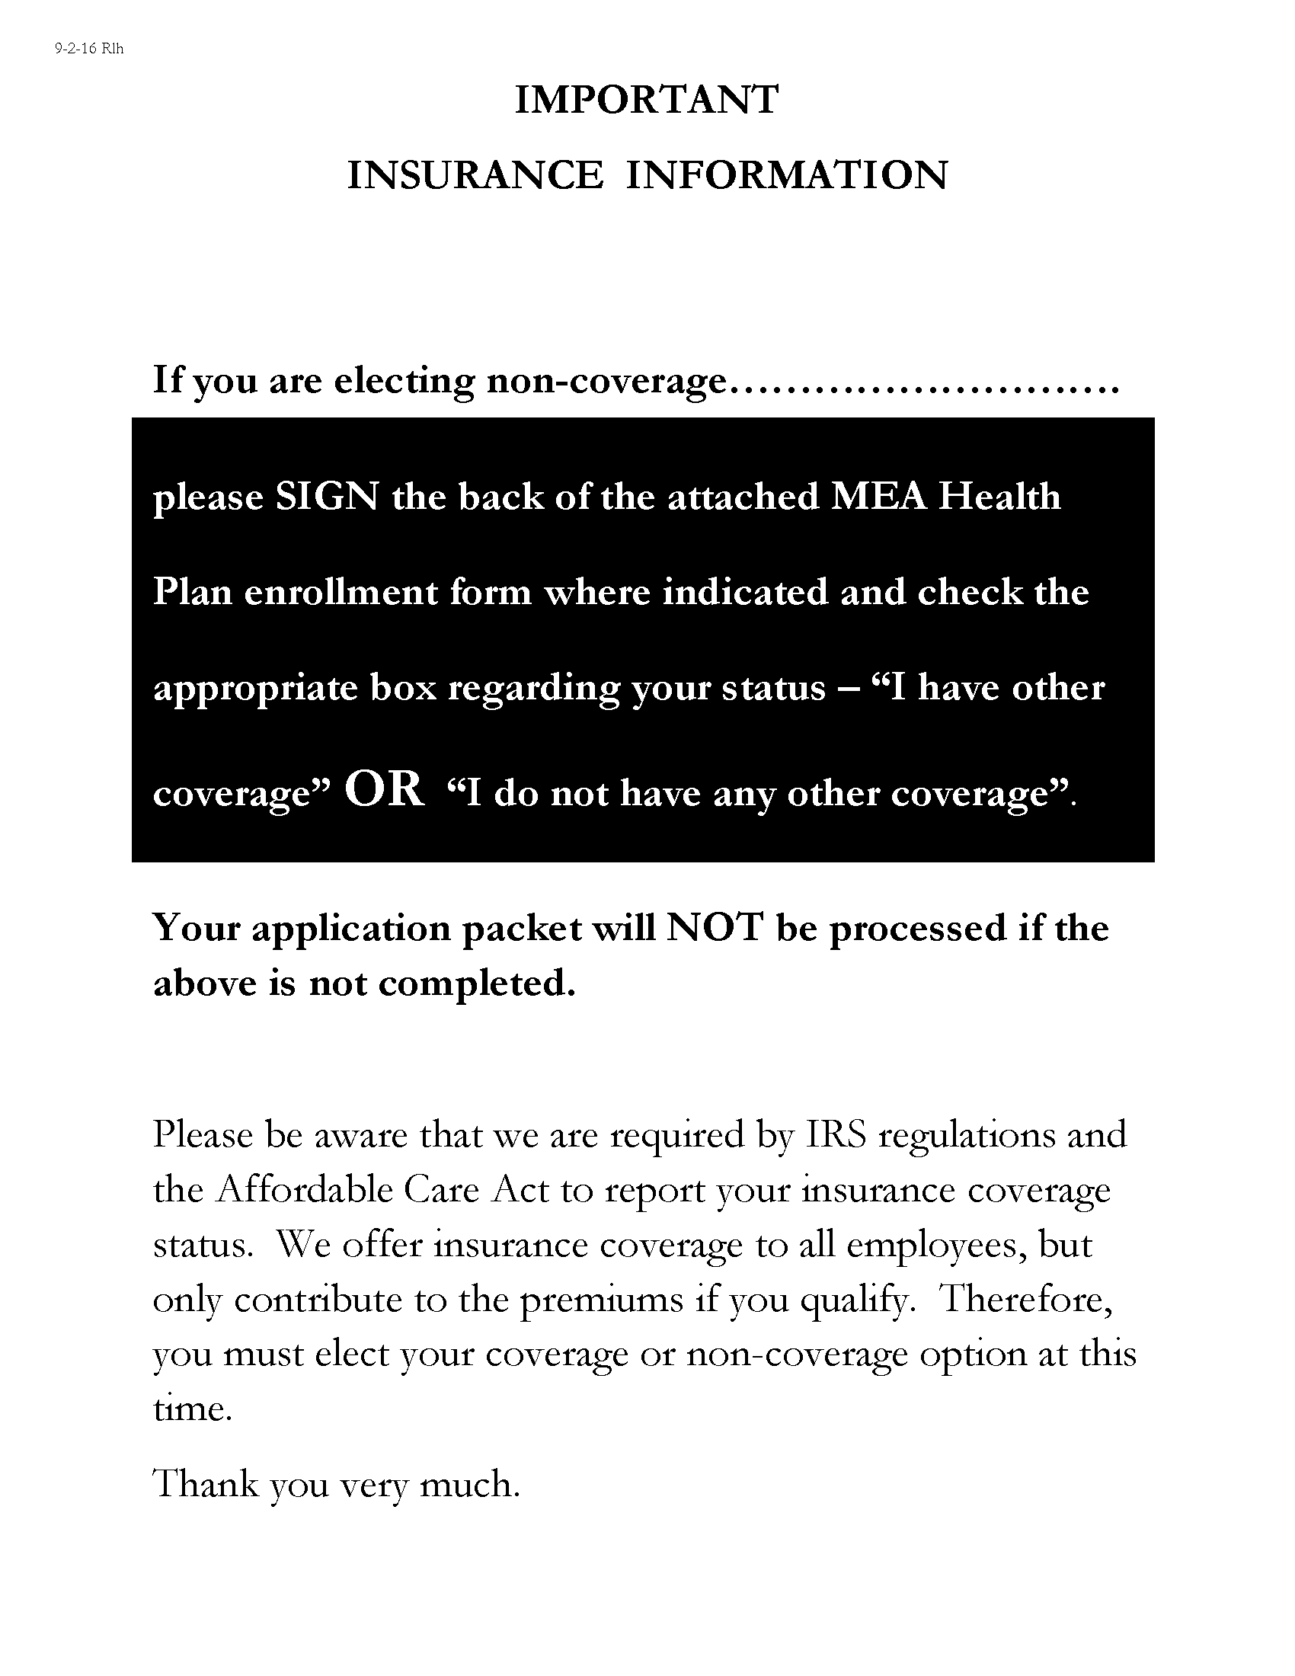

This Page Intentionally Left Blank

